Incident Description when triggered through API :

---------------------------------------------------------------------

Incident triggered :

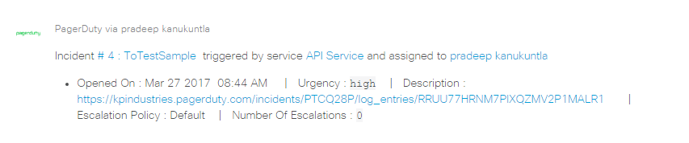

Incident acknowledge :

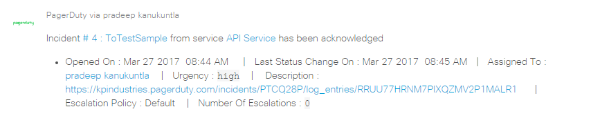

Incident resolved :

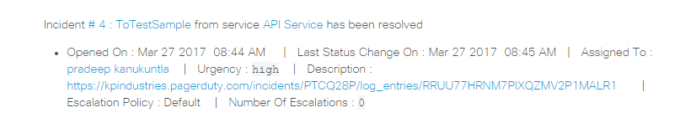

Incidents triggered through web :

--------------------------------------------------

Incident triggered :

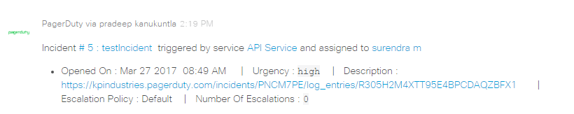

Incident assign :

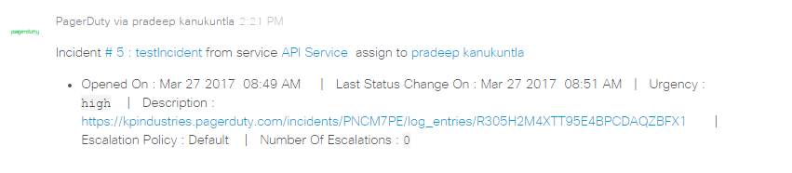

Incident escalate :

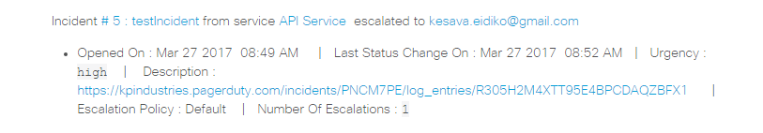

Incident delegate :

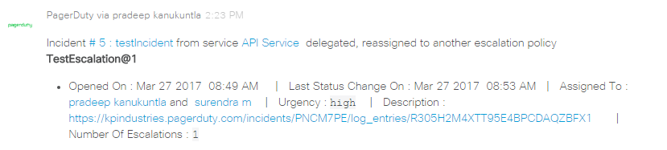

Incident acknowledge :

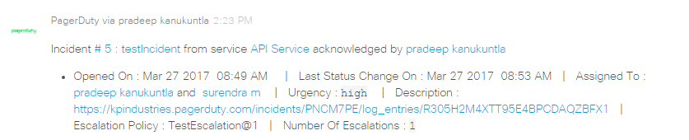

Incident resolve :

